**Vehicle Reservation**

**System**

**Use Case Document**

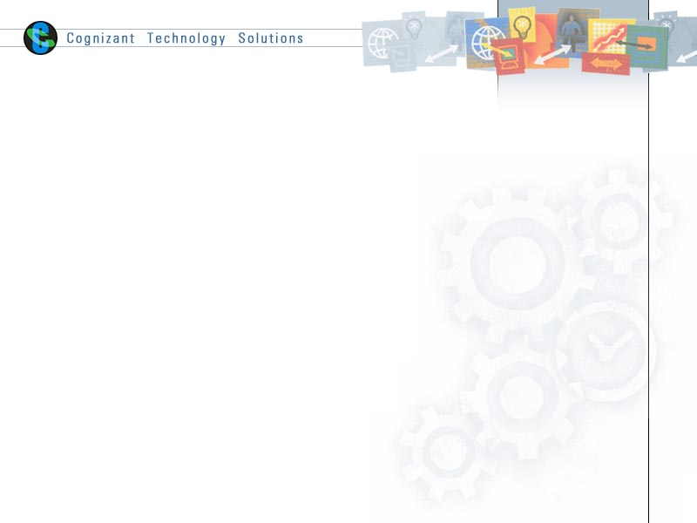

|  |  |  |  |
| --- | --- | --- | --- |
|  | Prepared By / Last Updated By | Reviewed by | Approved By |
| Name | Md Azhar  Pragya Das | Diksha Jaiswal  Shouvik Dey | Koyel Kujan Kundu |
| Role | Team Member | Team Member | Scrum Master |
| Signature |  |  |  |
| Date |  |  |  |

Table of Contents

1.0 Introduction 3

1.1 Purpose & Scope of the document 3

1.2 Intended Audience 3

1.3 Use case ‘User Registration’ 3

1.3.1 Use case attributes 3

1.3.2 Use Case Model 4

1.3.3 Business Rules 4

1.3.4 UI Requirements 4

1.3.5 UI Field Validations 5

1.4 Use case ‘User Credential Authentication’ 6

1.4.1 Use case attributes 6

1.4.2 Use Case Model 7

1.4.3 Business Rules 7

1.4.4 UI Requirements 7

2.0 Database Design 8

2.1 Tables Structure 8

3.0 Change Log 10

# Introduction

## Purpose & Scope of the document

The purpose of this Use case document is to systematically capture requirements for the project and the system to be developed in terms of use cases. Functional use cases are captured in this document. It also serves as the input for the project scoping.

The scope of this document is limited to addressing the use cases from a user, quality, and non-functional perspective.

## Intended Audience

Each member of the project team

## Use case ‘User Registration’

### Use case attributes

**Use Case Description:**

This use case deals with the capture of user details. The ‘user’ here shall be the operator of the system and will be keying in the patient information into the system.

**Scope:**

* User registration

**Actors:**

* User – the operator

**Trigger:**

Click ‘Submit’ button in the ‘User Registration’ page

**Pre-Condition:**

User being able to access the homepage & get redirected to the ‘User Registration’ page upon click of ‘Register if new’ link.

**Post Condition:**

User is in the enrollment page & submit details

**Flow of Events:**

User at homepage 🡪 Click ‘Register if new’ link 🡪 User is in the enrollment page 🡪 User details are submitted and added onto the database

**Primary Scenario:**

A new user – is able to click ‘Register if new’ link and able to provide his details and get enrolled in the system.

### Use Case Model

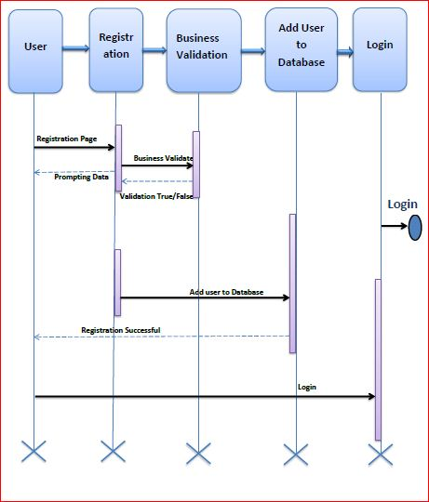

### Business Rules

Business rules should be defined using the following attributes: -

* When the user clicks on the registration link, it should re-direct to registration form.
  + - User needs to fill some of the basic attributes/fields as mentioned below in requirement: AdminId, First Name, Last Name, Age, Gender, Gender,Contact Number, User Id, Password and Branch.
* Clicking ‘Submit’ should validate the datatype constraints for each field
* Post-successful field level validation, save the information in the database
* Upon saving the information in the database, display the message ‘Your details are submitted successfully’.

### UI Requirements

Here is a prototype on how the homepage should look like.

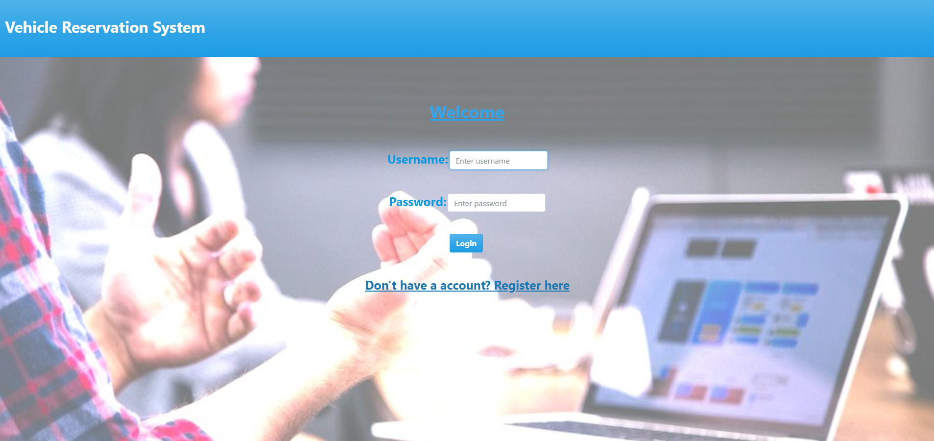

Here is a prototype on how the ‘User Registration’ page should look like.

### UI Field Validations

Please refer to the below requirements for field level validations:

* All fields are mandatory.
* Username should be less than 30 chars. Password should have minimum 8 chars, no space & can contain special characters (ex.!,@,#,%,*,& etc.)

Password and Confirm Password fields should be the same

* The Email ID format must be checked. (For ex. [test@testmail.com](mailto:test@testmail.com).)
* Phone Number must be of 10 digits’ length

## Use case ‘User Credential Authentication’

### Use case attributes

**Use Case Description:**

This use case deals with the authentication of the user credentials. The ‘user’ here shall be the operator of the system and will be keying in the Vehicle information into the system.

**Scope:**

* User credentials authentication

**Actors:**

User – the operator

**Trigger:**

Click ‘Login’ link, after keying in ‘AdminID’ & ‘Password’ field.

**Pre-Condition:**

User being able to access the homepage

**Post Condition:**

User is in the Vehicle Registration page

**Flow of Events:**

User at homepage 🡪 Key in ‘UserID’ & ‘Password’ field 🡪 User credentials are validated 🡪 Vehicle Registration page is displayed.

**Primary Scenario:**

A registered user – is able click ‘Login’ link, after keying in ‘UserID’ & ‘Password’ field and get his credentials authenticated with the existing database entry.

**Alternative Scenario:**

A registered user – is able click ‘Login’ link, after keying in ‘UserID’ & ‘Password’ field and unable to get his credentials authenticated. The user is presented with relevant error messages:

* Invalid User ID – ‘The userid provided does not exist in our records’
* Incorrect Password – ‘Password provided is incorrect. Please reach out to your system admin.’

### Use Case Model



### Business Rules

Business rules should be defined using the following attributes:-

* A registered user – is able click ‘Login’ link, after keying in ‘UserID’ & ‘Password’ field and get his credentials authenticated with the existing database entry.

### UI Requirements

Here is a prototype on how the Vehicle registration should look like.

# Database Design

## Data Model

### The following is a schematic view of the database design

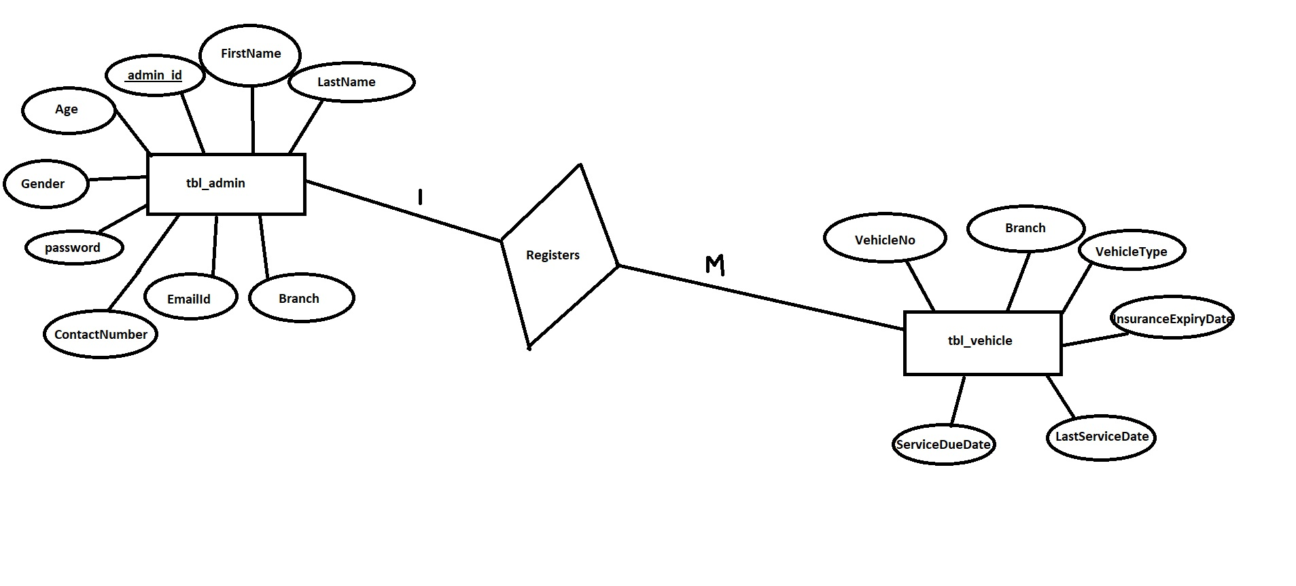

## Tables Structure

**User Information Table:**

|  |  |  |  |
| --- | --- | --- | --- |
| **Field Name** | **Field Type** | **Data Type** | **Possible Values** |
| Employee Id | Text(6) | Alphanumeric |  |
| First Name | Text(50) | Alphabetic |  |
| Last Name | Text(50) | Alphabetic |  |
| Age | Numeric(2) | Numeric |  |
| Gender | Drop Down | NA | Male,Female |
| Contact Number | Text(10) | Numeric |  |
| Email ID | Text(50) | Alphanumeric |  |
| Password | Text(15) | Alphanumeric |  |
| Branch | Text(5) | Alphanumeric |  |

**Vehicle Information Table:**

|  |  |  |  |
| --- | --- | --- | --- |
| **Field Name** | **Field Type** | **Data Type** | **Possible Values** |
| Vehicle No | Text(10) | Alphanumeric |  |
| Branch | Text(5) | Alphabetic |  |
| Vehicle Type | Text(15) | Alphabetic |  |
| Insurance Expiry Date | Text(10) | MM-DD-CCYY |  |
| Last Serviced Date | Text(10) | MM-DD-CCYY |  |
| Service Due Date | Text(10) | MM-DD-CCYY |  |

# Change Log

|  |  |  |  |  |
| --- | --- | --- | --- | --- |
| Version Number | Changes Made | | | |
| V1.0 | Initial baseline created on <dd-Mon-yy> by <Name of Author> | | | |
| V1.1 | <Please refer the configuration control tool / change item status form if the details of changes are maintained separately. If not, the template given below needs to be followed> | | | |
| **Section No.** | **Changed By** | **Effective Date** | **Changes Effected** |
|  |  |  |  |